Statement Regarding CV Inclusion in Bids Submitted by Bailey Partnership (Group) Ltd
Bailey Partnership (Group) Ltd is committed to providing comprehensive and transparent bids that clearly demonstrate both our capability and capacity to successfully deliver proposed projects.
To this end, we confirm that bids submitted by Bailey Partnership (Group) Ltd include CVs for key personnel proposed for the project. This practice ensures that our clients have the necessary information to evaluate the experience and expertise of our team, giving them confidence in our ability to execute the project to the highest standards.
The inclusion of CVs also provides clear evidence of our team's qualifications and relevant experience, allowing for a thorough assessment of our capability to undertake the work, and supports our demonstration of the capacity we have available to dedicate to the successful completion of the project.

SIgned 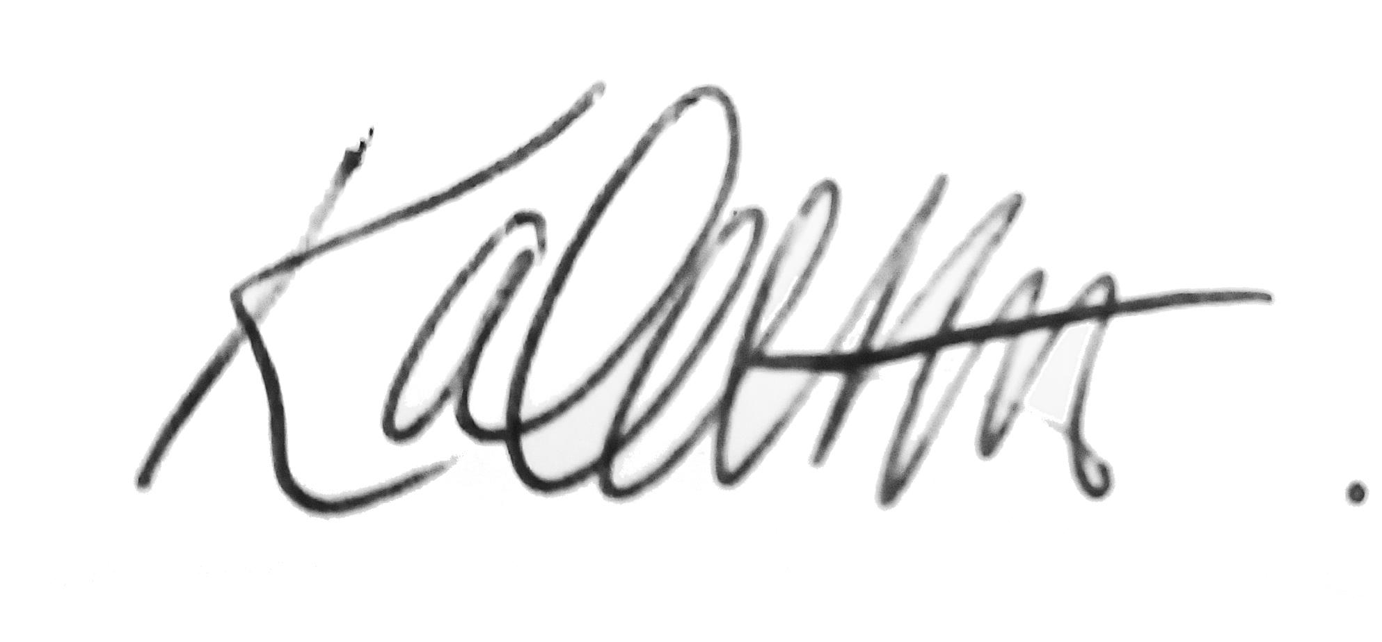________________

Name __Karen Alabaster-Oliver__________________

Position _Bid Writer____________________________

Date ____19 February 2025_____________________

